# Service vs Process; Background vs Foreground; Register a service

A process is said to run in the foreground if it interacts with users; otherwise, the process is said to run in the background. Processes run in the foreground, services run in the background.

A process is an instance of an executable file. A service in Windows is often an instance of svhost.exe process. There are some exceptions for this.

For a process to run as a service, it needs to register with Windows Service Control Manager.

Every service has to have some typical feature so that Windows Service Control Manager can manage the service’s start/stop/status. So, for a program to become a service, it has to follow some pattern.

# Environment Variables

An environment variable is a variable about the environment in which programs run in.

Every program runs in an environment. The environment is obviously the operating system, but here we mean more: an environment for a program is always restricted to the permission of the user that runs the program and many other parameters. So an environment is a limited space of the operating system.

All kinds of programs use environment variables to answer questions like: What’s the [name of the computer](https://www.digitalcitizen.life/change-computer-name-windows/) where I’m installed? What is the name of the user account that is running me? What is my current working directory? Where is Windows installed? Where are the temporary files stored on this computer? Where is the OneDrive folder for this user account?

There are two types of variables: user variables, specific to each user account, and system variables that apply to all user accounts.

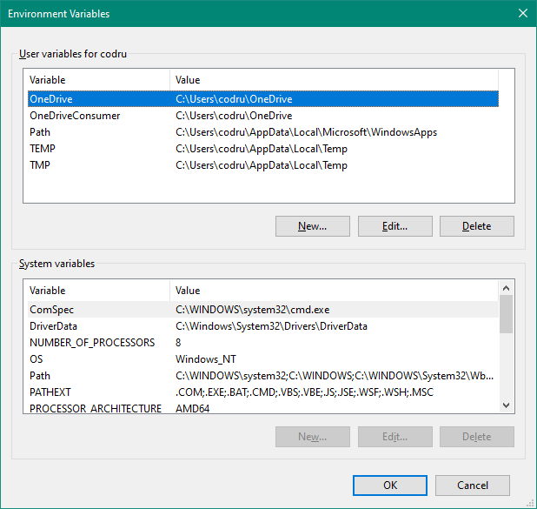

For CM:

View all the environment variables: set

View environment variable myVar: echo %myVar%

Assign value X for environment variable myVar: set myVar=X

# Shell

A shell is a [user interface](https://en.wikipedia.org/wiki/User_interface) for access to an [operating system](https://en.wikipedia.org/wiki/Operating_system)'s services. In general, operating system shells use either a [command-line interface](https://en.wikipedia.org/wiki/Command-line_interface) (CLI) or [graphical user interface](https://en.wikipedia.org/wiki/Graphical_user_interface) (GUI). It is named a shell because it is the outermost layer around the operating system.

Sometimes, a shell means just a command interpreter, and there comes terminals that provide user interface. So users type commands on terminal, and then terminal call shell to interpret user commands to system calls to the OS.

Bash shell is a popular Unix shell. It is used also on MAC.

# SSH (= secure shell)

“Secure Shell (SSH) is a cryptographic network protocol for operating network services securely over an unsecured network.”

This definition has 2 parts:

* SSH is a shell (i.e. a user interface) to operate network services. Bash shell is a user interface for controlling OS’s service, and now Secure Shell is a user interface for controlling network services.
* SSH is secured. It uses public key cryptography

# Fingerprint key

In public-key cryptography, a public key fingerprint is a short sequence of bytes used to identify a longer public key. Fingerprints are created by applying a cryptographic hash function to a public key.

# Installing software in Ubuntu